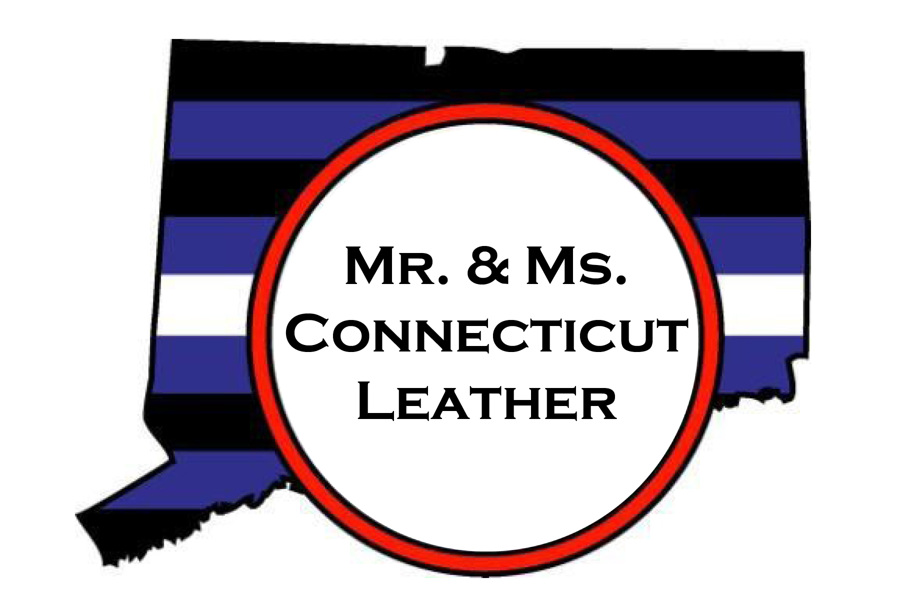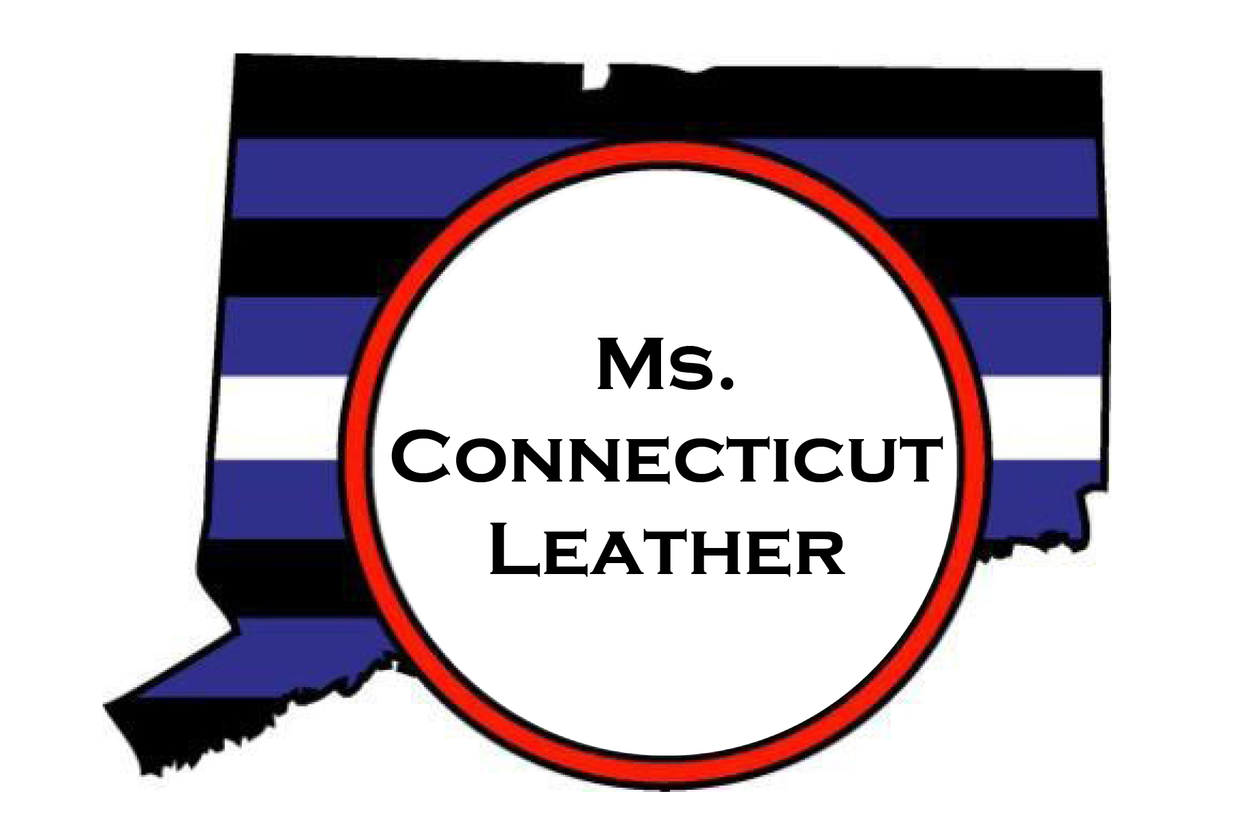

Advertising / Sponsorship Application

Thank you for taking time to look over the advertising and sponsorship information for the
Mr. and Ms. Connecticut Leather 2024 Contest!

This will be the 28th contest for male identified contestants, and the very first contest for female identified contestants! We are very excited about what this event has to offer our community and our sponsors - please visit www.mrctleather.org for more information. We know that the past year has been a challenge for everyone, including your ability to reach potential customers and clients.

The Mr. and Ms. Connecticut Leather 2024 Weekend will be held in downtown New Haven, CT the weekend of September 8 through 10, 2023.

With a dedicated and distinguished history, advertising with Mr. Connecticut Leather, Inc. will give you the opportunity to reach a significant number of individuals in the Leather, Bear and LGBTQ+ community.

You can be among the many businesses and organizations included in this publicity blitz.

Apply now! Our advertising deadline is rapidly approaching and we want to make sure you have the opportunity to reach out to and support this important market!

The deadline for submission of your sponsorship logo and payment is August 1, 2023.
The deadline for submission of your program logo/ad copy logo is August 15, 2023.

Please review the advertising application on the following pages and please do not hesitate to contact us if you have any questions.

Sincerely,

Mr. Connecticut Leather, Inc.
leather@mrctleather.org

Advertising Information

Name of business or organization:
Contact person: |  |  |  |  |  |  |  | Phone: ( |  | )
Email:: |  |  |  |  |  |  |  | Mobile: ( |  |  |  | )
Address:
City: |  |  |  |  |  |  | State/Prov.: |  |  |  | ZIP/PC:
Person selling the ad:

Ads must be 300dpi, JPG or PNG – and must be received with payment by the deadline of August 15, 2023 to be included in program book.
Except for the covers, all advertisements will be in black & white (grayscale) only.

Sponsor Logos, payments and ad payments must be received by August 1, 2023.
Completed ads can be emailed to leather@mrctleather.org

Advertising Costs
 |  | ------------- Gold Sponsor (includes full page ad) |  |  |  |  | Cost-$500
 |  | ------------- Silver Sponsor (includes half page ad) |  |  |  |  | Cost-$350
 |  |  | Full Page Advertisement: |  |  |  | Cost -$125
 |  |  | Half Page Advertisement |  |  |  | Cost - $85
 |  |  | Business Card Advertisement |  |  |  | Cost - $40
 |  |  | Full Page Back Cover - color (contact for availability before submitting) |  |  |  | Cost - $275
 |  |  | Full Page Inside Covers – color (contact for availability before submitting) |  |  |  | Cost - $225
Total Amount Enclosed $____________

Please remember to send your logos and payment to arrive before August 1, 2023 for Sponsors and by August 15,

2023 for ad inclusion in the program. Make checks payable to Mr. Connecticut Leather and list the ad name in the memo section. Mail payments to Connecticut Leather c/o Ian Rosman, 1108 Hanover Ave, Meriden, CT 06451. Contact leather@mrctleather.org or ctleather2017@gmail.com with questions or availability. Advertising is not considered final until payment is received. Mr. Connecticut Leather Inc. reserves the right to refuse to publish an advertisement for any reason.

Sponsorship Levels:

Gold Level - $500 Silver Level - $350

Multiple On-Stage acknowledgements
Recognition in Program Book
Logo on Website/Announced on social media
Banner hung prominently in venue
Full page ad in Program Book (premium placement)
2 Contest Admission Tickets

On-Stage acknowledgements Recognition in Program Book
Logo on Website

Half page ad in Program Book

In addition to sponsors, we are accepting gift baskets or other prizes for our Saturday night raffle during the contest. We are also accepting items to be given to the contest winners. If you wish to donate for either of these please contact us.
The names of all sponsors and prize donations will be announced
during the contest!

leather@mrctleather.org

On Facebook: Mr Connecticut Leather

Full Page Half Page Business Card

5.5”H x 4.25”V

5.5”H x 8.5

