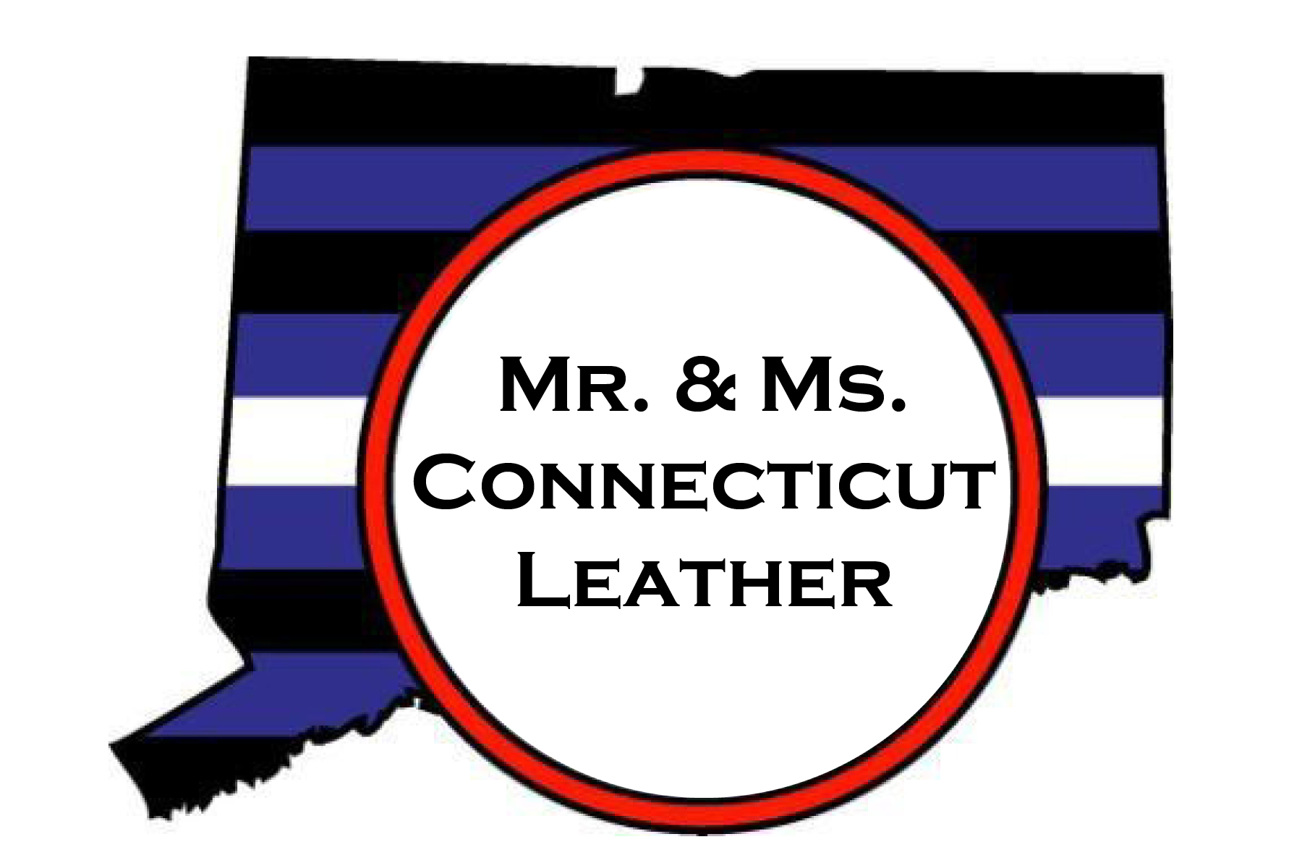

Mr. and Ms. Connecticut Leather 2024 Contestant Application
DEADLINE FOR SUBMITTAL IS SEPTEMBER 1, 2023
Send completed application to: leather@mrctleather.org or ctleather2017@gmail.com
(you may attached additional papers to this application if necessary)

Indicate which contest you are applying for: ____ Mr. or ____ Ms.

STAGE NAME:

PREVIOUS TITLES:

SPONSOR (optional):

CITY & STATE:

DATE OF BIRTH:

AGE:

HEIGHT: WEIGHT:

HAIR COLOR: EYE COLOR:

PREFERED PRONOUNS:

SPECIAL FEATURES:
(tattoos, piercings, etc.)

CURRENT RELATIONSHIP:
(Single, Lover, Master/slave, Daddy/Mommy, boy/boi/girl, Dom/sub, Handler/puppy, etc.)

OCCUPATION:

MEMBERSHIPS/ORGANIZATIONS:

FAVORITE VACATION SPOT:

HOBBIES:

WHAT ELSE SHOULD PEOPLE KNOW ABOUT YOU?

WHAT IS YOUR PRIMARY FETISH/KINK? WHY DO YOU ENJOY IT?

ARE YOU INVOLVED IN ANY VOLUNTEER ORGNAIZATIONS?

WHY ARE YOU ENTERING THIS CONTEST? WHAT DO YOU EXPECT OR HOPE TO GAIN FROM THE EXPERIENCE?

SPECIAL GOALS AND SATISFYING ACCOMPLISHMENTS:

WHAT DOES IT MEAN TO YOU TO BE A LEATHER PERSON?

CONFIDENTIAL INFORMATION: (WILL NOT BE ANNOUNCED ON STAGE)
Legal Name:

Street Address:
City/State/Zip:
Mailing Address:

(if different)
Phone Number:

E-Mail Address:

Mr. and Ms. Connecticut Leather 2024 Contestant Rules
REQUIREMENTS:
This contest is an event of the American LGBTQ+ community: Therefore, all contestants should be American (U.S. citizen or permanent resident), and must be at least 21 years of age and should self-identify as gay/lesbian, bisexual, trans, or queer. The Mr. Connecticut Leather Contest is open to all people who identify as a male and have an interest in leather and fetish. The Ms. Connecticut Leather Contest is open to all people who identify as female and have an interest in leather and fetish. Contestants for the Mr. Connecticut Leather contest must have a permanent residence in Connecticut or a neighboring state. Contestants for the Ms. Connecticut Leather Contest must have a permanent residence in Connecticut or another northeast state. If there are other questions about contestant eligibility, potential contestants may contact contest producers directly. While all are welcome to attend, these contests are not open to heterosexual contestants.

SUGGESTIONS:
Connecticut Leather does not provide hotel accommodations for contestants. It is mandatory that all contestants are available from 9 a.m. on Saturday, September 9, 2023 until the end of the contest (somewhere around 12 am). It is suggested that you attend the Friday night meet and greet and the Sunday Farewell Brunch also.

JUDGING METHOD:
The judges are titleholders and/or other prominent members of the leather community. In order to ensure fairness in selecting the winners of the contest, the Olympic Scoring System will be used. In the event of a tie, the non-Olympic scores (without the high/low exclusions) will be used to determine the winner. If both the Olympic and non-Olympic scores are tied, the judging panel will meet to break the tie. The Tally Master's final scoring sheet may be examined, upon request by contestants immediately following the contest and copies of their final scoring will be mailed to contestants at their request. Contestants and judges will be identified on the scoring sheets only by their numbers and letters (respectively). Keep in mind that judges do not necessarily look for
the most handsome face, most muscular and/or erotic body, but rather the person who best typifies the ideal leather person. This involves the personal subjective judgment of each contestant's leather image, physical appearance, attitude, personality, self-assurance, and "presence". The producers reserve the right to limit the number of contestants and/or impose an early elimination cut based upon partial judging to ensure the contest will be completed within the time frame allowed at the contest venue.

FRATERNIZATION WITH JUDGES:
Contestants and judges may fraternize informally in public situations. Private meetings between judges and contestants during the contest weekend are absolutely prohibited. Any personal sexual contact between judges and contestants during the contest weekend are absolutely prohibited. Any behavior that might create even the appearance of bias will be brought to the attention of the other judges, who will decide if the disqualification of the judge and/or contestant would be prudent.

JUDGING CATEGORIES:
Special Note:
Under State of Connecticut law, no genitalia shall be shown in public, or in pre-judging interviews.

There will be 4 judged categories
- Interview and Pre-judging: Individually, contestants will meet with the full panel of judges and respond to whatever questions asked. This interview will take place in private (off stage), without an audience. Attire should be comfortable, casual leather wear.
- Cruise Wear: Contestants will appear on stage in bar wear of their choice. At this time, the contestant will be introduced to the audience.
3a) Jock Strap On-Stage (male contestants): Contestants will appear in what they feel to be their "hottest" jock strap. Unlike many other contests, this segment is not an "exotic fashion show" or "body competition", but an exploration of our leather lifestyle, and will be judged as such. Each contestant should try to emphasize, by their choice of a jock strap, what they think looks the "hottest" to the audience and judges. At this time, the contest will be asked an on the spot question to which a quick response is all that is required.
3b) Hot Wear On Stage (female contestants): Contestants will appear on stage in what they feel to be their hottest leather/BDSM/fetish look. Similar to the male contest this is not an “exotic fashion show” or “body competition”, but an exploration of our leather lifestyle, and will be judged as such. Each contestant should choose garments that best reflect their leather background and attitude. So as to convey a clear message about themselves and their desires to the audience and judges. At this time, the contestant will be asked an on the spot question to which a quick response is all that is necessary.
- Formal Leather Image: Contestants will appear on stage in formal leather attire of their choice, will be given a question by the MC, and will give an answer not to exceed 120 seconds.
Single Contestants
In the event that either the Mr. or Ms. Connecticut Leather competitions are limited to a single contestant, that contestant must score a minimum of 75% of the total possible points. Should a contestant in this situation fail to earn the minimum number of points required, the title in question will not be awarded. The producers reserve the right to deviate from this procedure if they feel the circumstances warrant further consideration.

WHAT IS EXPECTED OF THE WINNER:
The primary duty of the winners is to represent the leather/BDSM and gay communities of Connecticut and promote the Mr. and Ms. Connecticut Leather title as a traveling ambassador. The winner of Mr. Connecticut Leather is requested to advance to regional, national, and/or international competitions. These include but are not limited to: Mid Atlantic Leather (MAL) or International Mr. Leather (IML). The winner of the Ms. Connecticut Leather contest is requested to advance to national and/or international competitions. These include but are not limited to International Ms. Leather (IMsL) or Women of Drummer contests. Any additional regional, national, or international leather titles not mentioned may also be acceptable. Any advancement to a regional, national and/or international title contest must be discussed and approved by the Mr. Connecticut Leather producers. Mr. or Ms. Connecticut Leather may not compete for any titles which would be considered below the state
level. This includes but is not limited to: bar titles, city/county titles, campground titles. While Connecticut Leather, Inc would be pleased to have the Connecticut titleholder advance to a higher level of competition within the greater leather community, it is also understood that issues of employment, finance, health, etc. may preclude titleholders from doing so responsibly or comfortably. We believe that the title year experience should be a positive one for both the titleholder and the community. We also believe that the most important obligation of our titleholders is to actively work to promote the leather lifestyle and the community within the State of Connecticut. One of the foremost expectations is that during their respective title year, they will conduct themselves as positive role models. Flagrant violation of this expectation may result in forfeiture of their title. In addition to raising funds to cover their own travels, the winners are
encouraged to help with fund raising projects for worthy causes.

Mr. and Ms. Connecticut Leather is expected to produce at least TWO benefits for a non-profit organization of his choice. That choice must be approved by the Connecticut Leather producers before the event has been advertised. During the title year, the titleholder is expected to attend all Connecticut Leather fundraisers and events wearing the sash or other appropriate title gear denoting their status as Mr. or Ms. Connecticut Leather. It is also encouraged that the Mr. and Ms. Connecticut Leather title holder attend Pride events through various communities (Hartford, New Haven, Norwalk, Middletown, ect) in Connecticut, and other regional evens in NYC, Boston, Providence, and New Jersey and further.
As winner, you will be provided with a Connecticut Leather sash which belongs to Mr. Connecticut Leather, Inc. and will be retained by the producers at their discretion. The Sash will be made available for your use and wear at the appropriate leather events during your title year. You will be responsible for purchasing a leather bar vest. Mr. Connecticut Leather, Inc. will arrange to have your title information applied to this vest for your title year. The winner’s travel fund will be dispensed in two parts. Half within 120 days of contest date, and the remaining portion at the successful completion of four S4 events and one regional or higher level contest

PHOTO RELEASE & WAIVERS
By signing this application, I am giving the producers of the Mr. and Ms. Connecticut
Leather Contest my permission to use my name, photos and likenesses in publicity, and
on the Internet. In addition I am releasing the Producers, Judges and Staff of the
Mr. and Ms. Connecticut Leather Contest as well as the Management and Staff of the
host venues of any liability that may occur during the contest or during my title
year. In addition I testify that I am over the age of 21.

CONTEST APPLICATION
Application must be completed and submitted by September 1, 2023. In signing this application, I acknowledge that I have read and fully understand terms and conditions set forth in the Contestant Rules within this application.

Contestant Signature (legal name only)

Contestant name printed Date Signed

Witness Signature:

Witness name printed Date Signed

For questions, please contact Connecticut Leather producers at leather@mrctleather.org, ctleather2017@gmail.com or 203-535-5441.
Updated 3/22/2023

