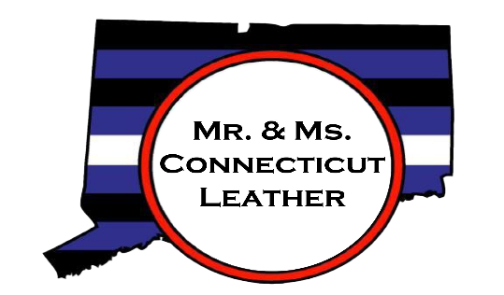
Spring 2026
Dear friends and community members,
Thank you for taking time to look over the advertising and sponsorship information for the
Mr. and Ms. Connecticut Leather 2027 Contest!
For more than 30 years, the Connecticut Leather Weekend has brought members of the community together for a weekend of fun and leather! We are very excited about what this event has to offer our community and our sponsors - please visit www.mrctleather.org for more information. We know that due to inflation and the current political climate, your organization’s budget may be in flux, as is ours. As an all-volunteer organization, all money donated goes towards our event. Connecticut Leather is asking for your assistance. We promise that your business and/or organization will be publicly recognized for your contributions multiple times to help promote not only the event weekend, but also to promote the services your organization offers or the products you sell.
The Mr. and Ms. Connecticut Leather 2027 Weekend will be held in downtown New Haven, CT the weekend of September 11 through 13, 2026.

With a dedicated and distinguished history, advertising with Connecticut Leather, Inc. will give you the opportunity to reach a significant number of individuals in the Leather, Bear and LGBTQ+ community.
Apply now! Our advertising deadline will approach quickly, and we want to make sure you have the opportunity to reach out to, support, and be seen by the Connecticut community! We have new sponsorship level that can fit any business or individual budget.
The deadline for submission of your sponsorship logo and payment is August 1, 2026.
The deadline for submission of your program logo/ad copy logo is August 15, 2026.
Please review the advertising application on the following pages and please do not hesitate to contact us if you have any questions.
Sincerely,

Connecticut Leather, Inc.
leather@mrctleather.org
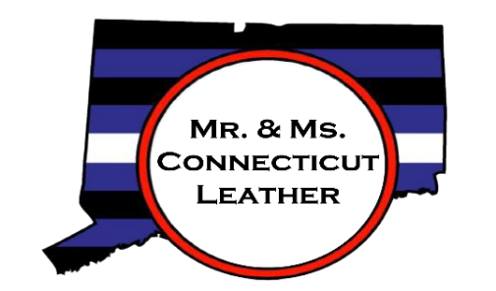
SPONSORSHIP LEVELS
Platinum Level ($1000+) ONLY THREE AVAILABLE
Multiple spoken acknowledgements from stage
Full page COLOR ad in program book (5.5” Horizontal x 8.5” Vertical)
Logo on CT Leather website, social media, and printed materials (must be reserved by July 15)
Complementary admission for two people to contest
Opportunity to address crowd from stage (up to 2 minutes) to discuss your organization
Complementary admission for two to private cocktail party with judges, staff, and contestant
Gold Level ($750- 999)
Listed as sponsor in program book
Multiple spoken acknowledgement from stage
Full page (black and white) ad in program book (grey scale) (5.5” Horizontal x 8.5” Vertical)
Logo on CT Leather website, social media, and printed materials (must be reserved by July 15)
Complementary admission for two people to contest
Silver Level ($400- 749)
Listed as sponsor in program book.
Multiple Spoken acknowledgement from stage
Half page ad in program book (5.5” Horizontal x 4.25” Vertical)
Logo placed on CT Leather website and social media
Bronze Level ($250-399)
Listed sponsor in program book
Spoken acknowledgment from stage
Quarter page ad in program book
Logo placed on CT Leather website
Blue Level ($100-249)
Listed as sponsor in program book
Spoken acknowledgement from stage
Friends of Leather ($50-99)
Listed as sponsor in program book

In addition to weekend sponsors, we are also accepting in-kind donations of gift baskets, gift cards, or other prizes for our Saturday night raffle during the contest. Additional items can be designated as prizes to the contest winners. If you wish to donate for these opportunities, please contact us.

The names of all sponsors and prize donations will be announced
during the contest!

Leather@mrctleather.org

On Facebook or Instagram: Connecticut Leather

ADVERTISING INFORMATION
Name of Business or Organization: ___________________________________________________________________________
Contact person: ___________________________________________________________
Contact person’s email: ____________________________________________________
Contact person’s phone: ___________________________________________________
Mailing address: ___________________________________________________________
___________________________________________________________________________

Sponsor Logos, payments and ad payments must be received by August 1, 2026.
Please send in PDF, JPEG or PNF format
Scan completed sponsor form to both emails provided: leather@mrctleather.org or CTLeather2017@gmail.com, or send paper copy to address below.
Advertising Costs
__________ Platinum Sponsor ($1000+) color full page ad
__________ Gold Sponsor ($750-999) grey scale full page ad
__________ Silver Sponsor ($400-749) grey scale half page ad
__________ Bronze Sponsor ($250-399) quarter page ad
__________ Blue Sponsor ($100-249)
__________ Friends of Leather ($50-99)
Please remember to send your logos and payment to arrive before August 1, 2026 for Sponsors and by August 15,
2026 for ad inclusion in the program. Make checks payable to Connecticut Leather and list the ad name in the memo section. Mail payments to Connecticut Leather, c/o Ian Rosman, 1108 Hanover Ave, Meriden, CT 06451. Contact leather@mrctleather.org and cc: ctleather2017@gmail.com with questions or availability. Advertising is not considered final until payment is received. Connecticut Leather Inc. reserves the right to refuse to publish an advertisement for any reason.

